THE DEEP WEB

A Project Report Submitted
for

Information Technology
By

Kamla Pandey
(Roll no. 11)

Under the guidance of
Mr. Praveen Kumar Joshi



EVER GREEN SENIOR SECONDARY SCHOOL
(GOVERNED BY EDUCATIONAL WELFARE SOCIETY)
TULARAMPUR - 263139, DISTRICT-NAINITAL
UTTARAKHAND, INDIA

OCTOBER, 2021

CERTIFICATE

This is to certify that the project entitled “the deep web” being submitted to Ever green Senior Secondary School, Haldwani for the project work of INFORMATION TECHNOLOGY is a record of the work carried by MR. PRAVEEN KUMAR JOSHI under my guidance and supervision.

Date: Supervisor
MR. PRAVEENJOSHI
TGT Computer
Ever Green Sr. Sec. School, Haldwani
Forwarded By:
MR. M.S. PARWAL
Principal
Ever Green Sr. Sec. School, Haldwani

ABSTRACT
This document is about the hidden web the invisible web it is about the deep web. In this presentation we learn what is deep web? Why we use deep web? How to use it, difference between the common web the surface web and deep web, What is dark web why it is illegal about its resources and few other information.

ACKNOWLEDGEMENTS
I would like to express my most sincere heartfelt gratitude and respect to my supervisor MR. PRAVEEN JOSHI, for suggesting the topic for my project work and for his excellent guidance, valuable suggestions and endless support throughout for preparing the report. I am greatly indebted to him for his constructive suggestions and criticism from time to time during the course of progress of my work.
I would like to express my gratitude and sincere thanks to Mr. M.S. Parwal, Principal of School, and entire faculty who has imparted considerable knowledge to me.
Finally, I express my deepest gratitude to my parents for their continuous encouragement, understanding and support.

(KAMLA PANDEY)

TABLE OF CONTENTS

Chapter | Topic | Page No.
 | CERTIFICATE
 | ACKNOWLEDGEMENT
 | LIST OF FIGURES
 | ABSTRACT
1. | INTRODUCTION
2. | history | 1
3. | What make it deep? | 2
4. | Deep web resources | 3
5. | Why deep web | 4
6. | When to use the deep web? | 5
7. | How to search the deep web? | 6
8. | What tool to be used | 7
9. | conclusion | 8
10. | summery | 9
11 | future | 10

LIST OF FIGURES

S.No. | Name | Page No.
1. | Deep web v/s surface web
2. | Webs
3. | TOR
4. | Worldwidescience.org
5. | Info mine
6. | Complete planet
7. | Tech extra

THE DEEP WEB
CONTENT
Introduction
History
What make it deep?
Deep web resources
Why deep web?
When to use the deep Web?
How to search the deep web?
What tool to be used?
Conclusion

INTRODUCTION
Deep web is defined as the content on the web that is not accessible through a search on general search engines.
This content is sometimes also referred to as the invisible or hidden web.
Deep web content includes information in private database that are accessible to be crawled by search engines.
Most of the search engines are only designed to search the surface of the web and they deliver less than 10% of the available internet information.
DEEP WEB V/S SURFACE WEB
Public information on the deep web is currently 40 to 550 times larger than the commonly defined on World Wide Web.
The deep web contains 7500TB of information compared to 19 TB of information on the surface of web.
The deep web contains nearly 550 billion individual documents compared to the 1 billion of the surface web.
More than 200,000 deep web sites presently exist.
60 of the largest deep web sites collectively contain about 750 TB of information sufficient by themselves exceed the size of the surface web 40 times.
On average ,deep web sites receives 50% greater monthly traffic than surface sites and are more highly linked than surface sites; however , the typical deep web sites is not well known to the internet-searching public.
Total quality content of the deep web is 1000 to 2000 times greater than that of the surface web.
Deep web content is highly to every information need, market and domain.
A fuel 95% of the deep web is publically accessible information not subject to fees or subscription.
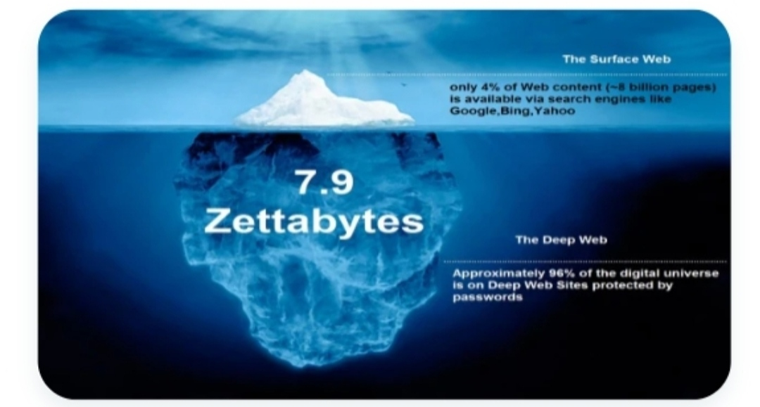
Figure 1: Deep web v/s surface web

HISTORY OF DEEP WEB
Jell Ellsworth used the term invisible web in 1994 to refer to website that are not registered with any search engine.
- In 1996 frank Garcia in an article said that “it would be a site that’s possibly reasonably designed but they didn’t bother to register it with any of the search engine so no one can find them you ‘re hidden i call that the invisible web”
- Another early use of invisible web was by Bruce Mount at Matthew B in a description of the @deep web tool found n a December 1996 press release.
- In 2001 the first use of the specific term deep web was generally accepted.

WHAT MKE IT DEEP
Search engines typically do not index the following type of web sites:
- Proprietary sites
- Sites requiring a registration
- Sites with scripts
- Dynamic sites
- Ephemeral sites
- Sites blocked with special formats
- Searchable database

DEEP WEB RESOURCES
- Dynamic contents
- Unlinked content
- Private web
- Contextual web limited access content
- Scripted content
- Non-HTML/text content

DYNAMIC CONTANT

- Dynamic pages which are returned in response.
- To a submitted query or accessed only through a form.
- Especially if open-domain input navigate without domain knowledge.

UNLINKED CONTENT
- Pages which are not linked to by other pages.
- Which may prevent web crawling programs from accessing the content.
- This content is referred to as pages without in links.

PRIVATE WEB
- Sites that require registration a login (password protect resources).

COTEXTUAL WEB
- Pages with content varying for different access context (e.g., range of client IP address or previous navigation sequence.

LIMITED ACCESS CONTENT
- Sites that limit access to their pages in technical way (e.g., using the Robots Exclusion standard, CAPTCHAs, no cache HTTP headers which prohibit search engines browsing them and creating cached copies.

SCRIPTED CONTENT
- Pages that are only accessible through links produced by Java Script as well as content dynamically downloaded from web services via Flash or Ajax Solutions.

NON- HTML/TEXT CONTENT
- Textual content encoded in multimedia (images or video0 files or specific files formats not handled by search engines.

WHY DEEP WEB?
- Quality of content /bigger level of authority
- Comprehensiveness
- Focused
- Timelines
- The material isn’t available elsewhere on the web

WHRN TO USE THE DEEP WEB

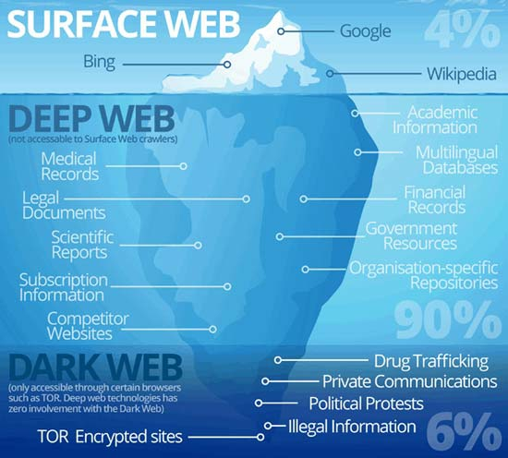
webs
Standard search engines aren’t working
- A precise answer is needed
- Data or statistics are needed
- High quality or authoritative results are needed
- When timeline is important
- You know the subject area well
- Looking for collection[mages, sounds, manuscripts]
- Reference book online [handbook, guides, dictionaries, encyclopaedias, directories etc].

HOW TO SEARCH THE DEEP WEB?
- Determines the specific topic you need to find.
- Categorize your topic
- Decide what type of source you’d like to search.
- Choose your staring point based on your objective.

DEEP POTENTIAL
- The deep is an endless repository for a mind reeling amount of information.
- Its powerful it unleashes human nature in all its forms, both good and bad.
- There are engineering database, financial information of all kinds, medical papers, pictures, illustration.... the list goes on. Basically forever.
- For example, construction engineers could potentially search research paper at multiple universities in order to find the latest and greatest in bridge building materials.
- Doctors could swiftly locals research on a specific disease.
- The potential is unlimited. The technical challenges are daunting that’s the draw of the deep web.

SHADOW LAND
- The deep web may be a shadow land of untapped potential.
- The bad stuff as always gets most of the headlines.
- You can find illegal goods and activities of all kinds through the dark web.
- That includes drugs child pornography, stolen credit card number, human trafficking weapons, exotic animals, copy righted media and anything else. You can think of.
- Theoretically you could even, say hire a hit man to kill someone you don’t like.
- But you don’t find this information with GOOGLE search.
- This kind of web sites require you to use special software such as the onion router, more commonly known as TOR.

THE ONION ROUTER (TOR)

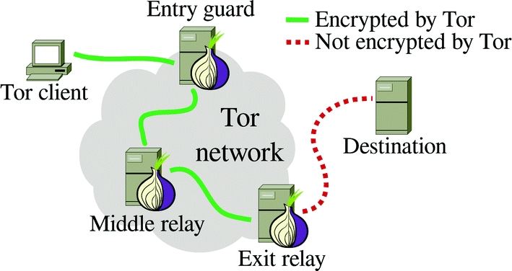

- Tor is software that installs in your browser and setup the specific connections you need to access dark web sites.
- Critically it is free software for enabling online anonymity and censorship resistance.
- Onion routing refers to the process of removing encryption layers from internet communications, similar to pulling back the layer of an onion.
- Using tor makes it more difficult to trace internet activity including “visits to web sites, online posts, instant messages other communication forms”, back to the user.
- It is intended to protect the personal privacy of users. As well as their freedom and ability to conduct confidential business by keeping their internet activities from”, back to the user.

WHAT TOOLS TO BE USED?
- Worldwidescience.org


Worldwidescience.org

- Global science gateway to national and international scientific databases.

- Info Mine
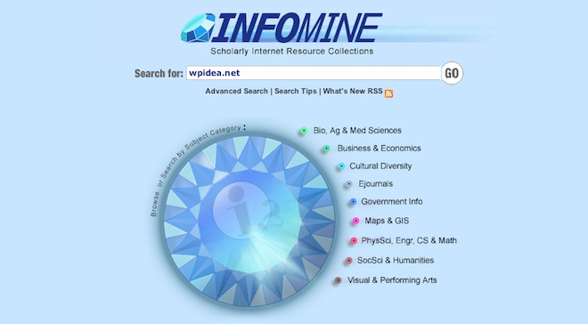
Info mine

- It has been built by a pool of libraries in the United State. You can search using the search options.
- Complete planets

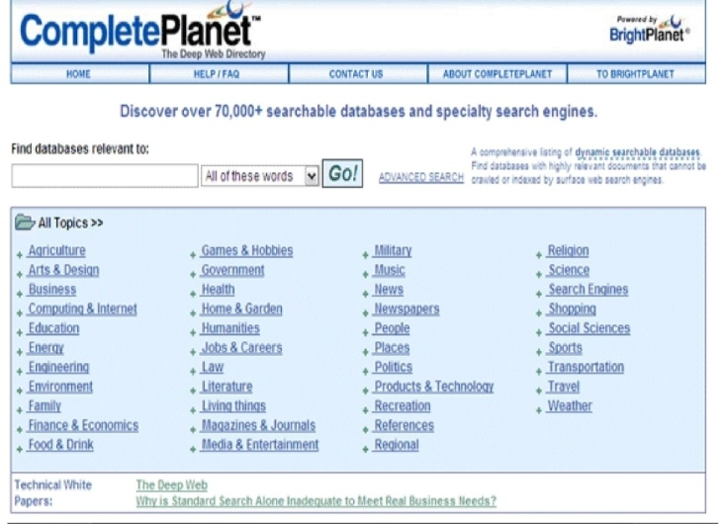
Complete planet

- Calls itself the ‘front door’ to the deep web. This free and well designed directory resource makes it easy to access the mass of dynamic databases that are cloaked from a general purpose search. The databases indexed by complete planet number around 70,000 and range from agriculture to weather. Also thrown in are database like food &drink and military.

- Tech extra

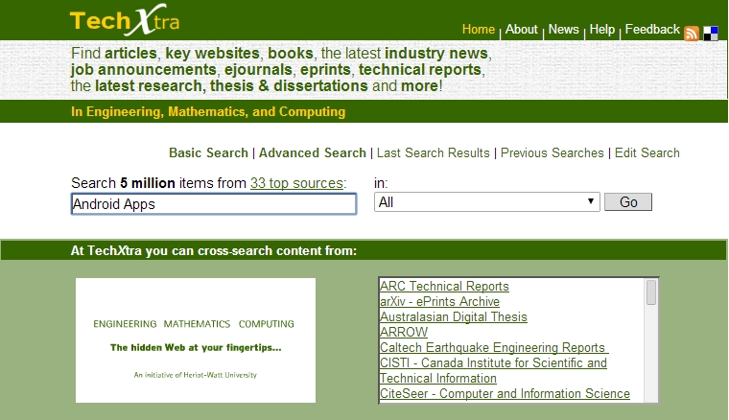
Tech extra

- It concentrates on engineering, mathematics and computing. It gives us industries news, job announcements, technical reports, technical data, full text, teaching and learning resources along with articles and relevant website in formation.
CONCLUSION
- The deep web contains valuable resources that are not easily accessible by automated search engines but readily available to enlightened searchers.
- It makes the online search process more efficient and productive as it constitutes the resources missed in the surface web.

- SUMMERY
- The deep web gives users accessed to far more information than the surface web. This information may simply be pages that aren’t important to be listed. However, it also includes the latest TV shows, databases that are essential for managing your personal finances, and stories that are censored on the surface web.
Deep web content includes email messages, chat messages, private content on social media sites, electronic bank statements, electronic health record (EHR) and other content that is accessible one way or another over the internet. There are quite differences between deep web and dark web like – the dark web is the WWW content that exists on dark net, overly networks that use the internet but required specific software, configurations, or authorizations to access. The deep web is that part of the internet that is not visible to the naked eyes as to the surface web. The deep web is that type of web which is still unknown for many peoples.
FUTURE
- The lines between search engine content and deep web have begun to blur, as search services start to provide access to part or all of once- restricted content.
- An increasing amount of deep web content is opening up to free search as publishers and libraries make agreements with large search engines.
- In the future, deep web content may be defined less by opportunity for search than by access fees or other types of authentications.

